

UNIVERSITY INSTITUTE OF COMPUTING

Project on
“COMPLAINT MANAGEMENT SYSTEM”

Program Name: BCA
SUBJECT NAME: ADVANCED WEB DEVELOPMENT
SUBJECT CODE: 23CAH-302
Submitted To: Mr. Abhineet Thakur
Designation: Assistant Professor

Submitted By : Jasman , kanan
Uid : 23bca10327, 23bca10353
Section : 2
Group : A

Source Code:
<?php
namespace App\Http\Controllers;
use Illuminate\Http\Request;
use App\Models\Complaint;
use Illuminate\Support\Facades\Auth;
class ComplaintController extends Controller
{
public function index()
{
$complaints = Auth::user()->complaints()->latest()->get();
return view('complaints.index', compact('complaints'));
}
public function mycomplaints()
{
$complaints = Auth::user()->complaints()->latest()->get();
return view('complaints.mycomplaints', compact('complaints'));
}
public function create()
{
return view('complaints.create');
}
public function store(Request $request)
{
$request->validate([
'title' => 'required|string|max:255',
'description' => 'required|string',
]);
Complaint::create([
'user_id' => Auth::id(),
'title' => $request->title,
'description' => $request->description,
'status' => 'pending', // default status
]);
return redirect()->route('complaints.index')
->with('success', 'Complaint submitted successfully!');
}
public function show(Complaint $complaint)
{
$this->authorizeComplaint($complaint);
return view('complaints.show', compact('complaint'));
}
public function edit(Complaint $complaint)
{
$this->authorizeComplaint($complaint);
return view('complaints.edit', compact('complaint'));
}}
<?php
use Illuminate\Support\Facades\Route;
use App\Http\Controllers\ComplaintController;
use App\Http\Controllers\ProfileController;
use App\Http\Controllers\AdminController;
use App\Http\Controllers\AdminComplaintController;
Route::get('/', fn() => view('welcome'))->name('welcome');
require __DIR__.'/auth.php';
Route::middleware(['auth'])->group(function () {
Route::get('/dashboard', fn() => redirect()->route('complaints.index'))->name('dashboard');
Route::resource('complaints', ComplaintController::class);
Route::get('/my-complaints', [ComplaintController::class, 'myComplaints'])->name('complaints.my');
Route::prefix('profile')->name('profile.')->group(function () {
Route::get('/', [ProfileController::class, 'show'])->name('show');
Route::get('/edit', [ProfileController::class, 'edit'])->name('edit');
Route::patch('/update', [ProfileController::class, 'update'])->name('update');
Route::delete('/delete', [ProfileController::class, 'destroy'])->name('destroy');
});
});
Route::middleware(['auth', 'admin'])->prefix('admin')->name('admin.')->group(function () {
Route::get('/dashboard', [AdminController::class, 'dashboard'])->name('dashboard');
Route::get('/users', [AdminController::class, 'users'])->name('users.index');
Route::get('/users/{id}', [AdminController::class, 'showUser'])->name('users.show');
Route::delete('/users/{id}', [AdminController::class, 'deleteUser'])->name('users.destroy');
Route::resource('complaints', AdminComplaintController::class)->except(['create', 'store']);
Route::get('complaints/{complaint}/reply', [AdminComplaintController::class, 'reply'])->name('complaints.reply');
Route::post('complaints/{complaint}/reply', [AdminComplaintController::class, 'sendReply'])->name('complaints.sendReply');
});

Screenshots of Results:

1.Welcome page:
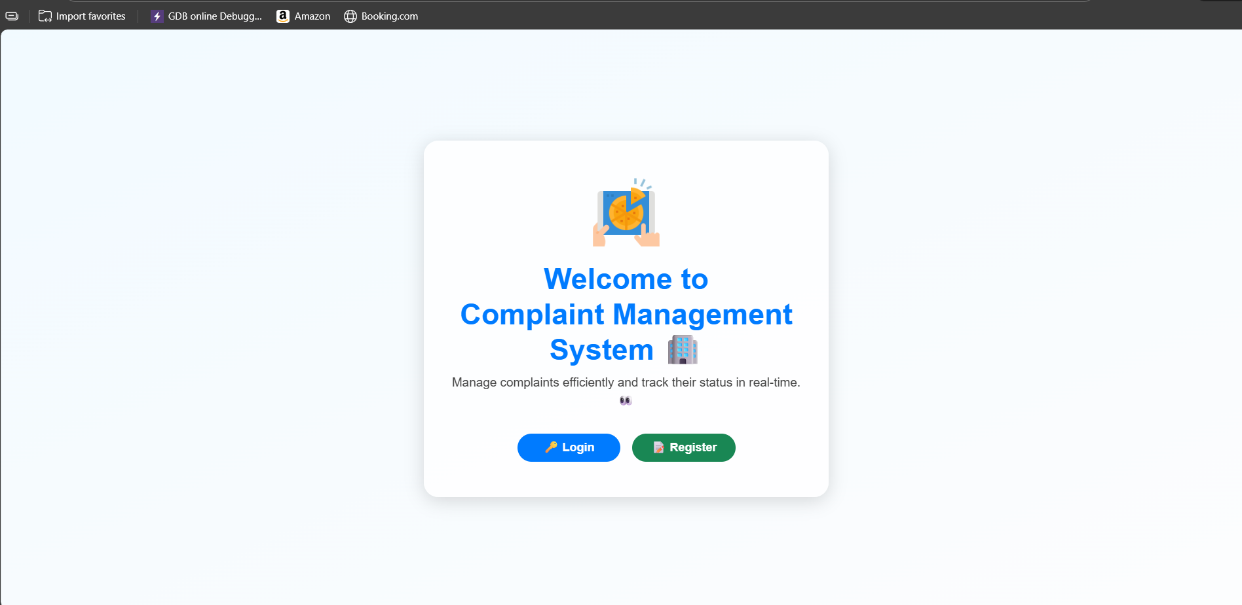

2. User Login/Registration: 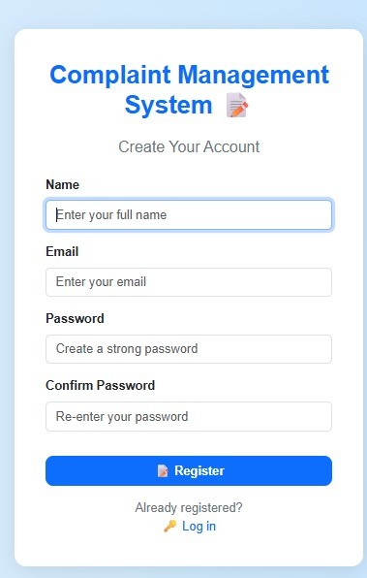
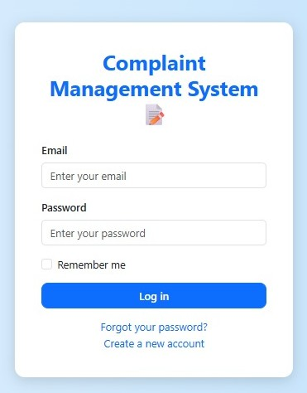

3.User Dashboard:
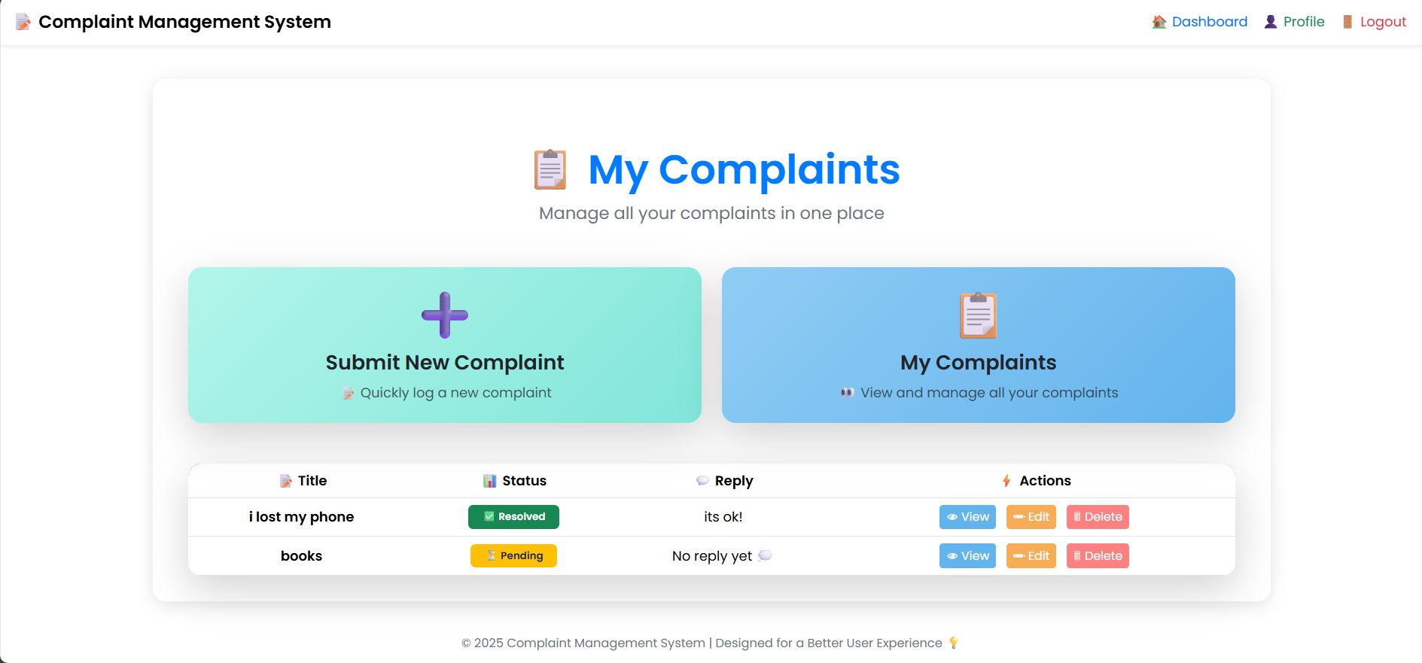

4.Complaint Submission:
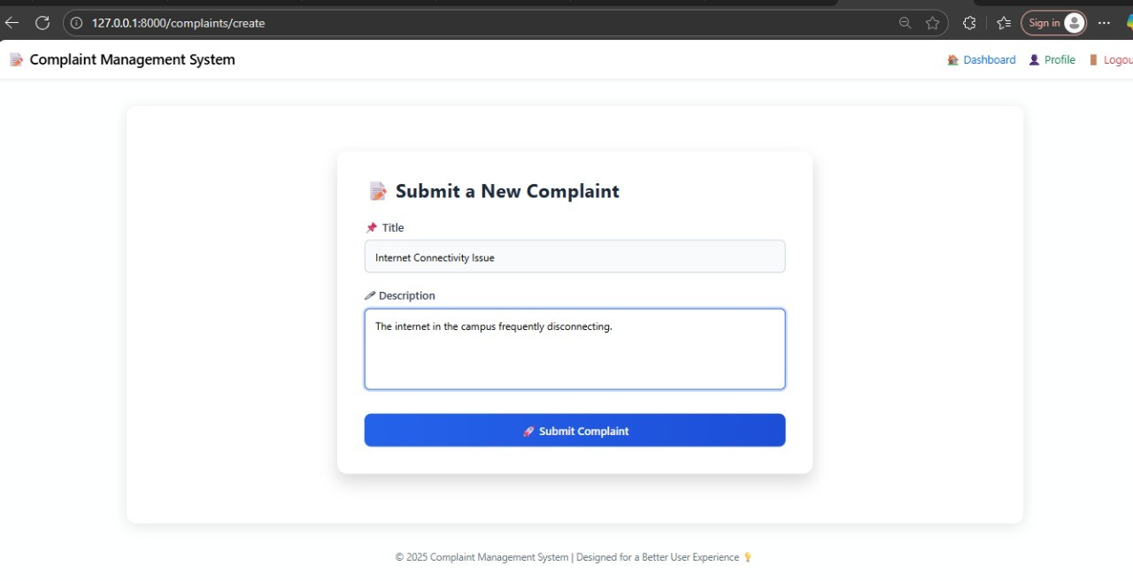

5.Admin Dashboard:
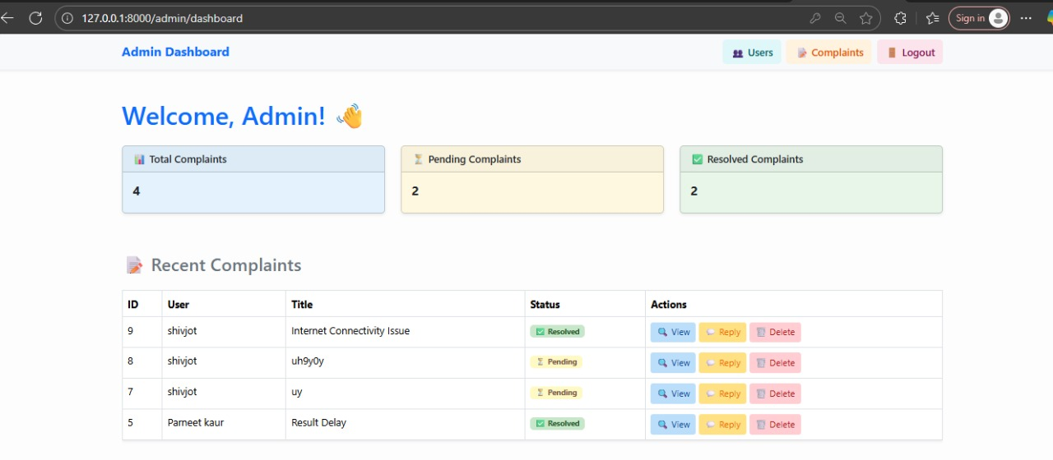

6.Complaint Resolved View:
